**MESD LMS Documentation – View all students enrolled into a teacher’s class or subject**

**Purpose**

To be able to view all students enrolled into a teacher’s class or subject.

**Background**

This module handles requests directly from Educators within the Moodle system, allowing functionality to view all students enrolled into that Educator’s class or subject.

**Usage**

**View students enrolled into a class or course/subject**

1. Login as an Educator.
2. Go to ‘*Home*’.
3. Click on the course to want to view.
4. Go to ‘*Participants*’.

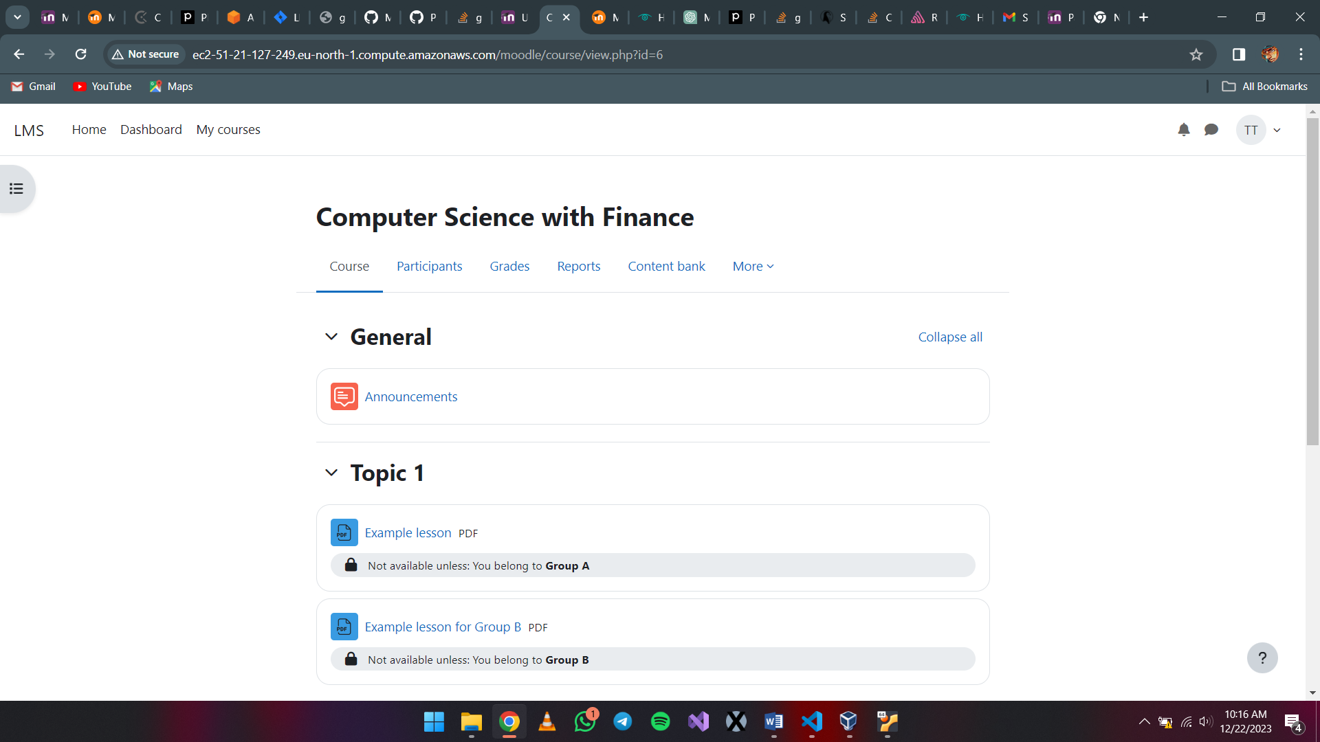

You can now view every participant under that course/subject.

